Activity 04  | P1 | P2 | P3 | P4 | P5 | P6

# **Activity 04:**

**Functions**

[Def myFunction ()](https://www.programiz.com/python-programming/function)

*#program does nothing as written*

**Def** **happyBirthday** (**Name**):

print ("Happy Birthday to you!")

print ("Happy Birthday to you!")

print ("Happy Birthday, dear " + **Name**)

print ("Happy Birthday to you!")

**# This is the Call Statement**

happyBirthday **(Name)**

Here are **simple** rules to **define** a **function** in **Python**.

**Function** blocks begin with the keyword **def** followed by the **function** name and parentheses ( ) . Any **input parameters** or arguments should be **placed within these parentheses**.   
You can also **define** parameters inside these parentheses.

Use your school **OneDrive** store your Digital Solutions work.  
Naming Convention required = **DS_Surname_FirstName_ID**

**Eg DS_Mathews_Mike_0123456**

Save this file to that Folder as **“Activity04.docx”**

Note: you will also save the python files (x6)

eg **Act04_proj1**.py ( + Act04_proj2….…proj6 )

Activity 04  | P1 | P2 | P3 | P4 | P5 | P6

# **Project 1**

|  |
| --- |
| What is your Name :Patrick  Happy Birhday to you  Happy Birhday to you  Happy Birthday dear Patrick  Happy Birhday to you |

Write a Python program has a welcome Function defined and uses a **Name Variable** to be entered by the user and used in the happy Birthday Song.

Sample **output** should

look like this:

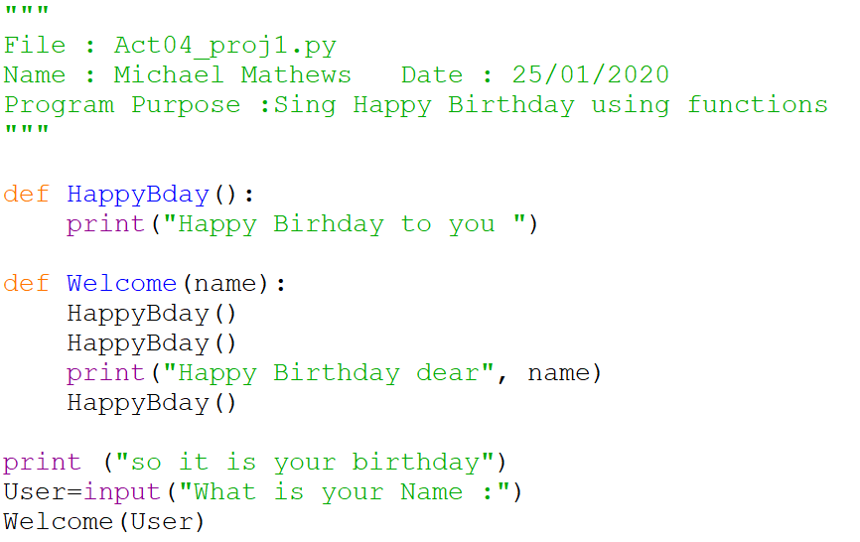

Activity 04  | P1 | P2 | P3 | P4 | P5 | P6

# **Project 2**

|  |
| --- |
| Enter the Base of the Rectangle :12  Enter the Height of the Rectangle :5  Area of the Rectangle is : 60.00  Perimeter of the Rectangle is : 34.00 |

Write a Python program uses

**Def** functions for calculating

the area and perimeter of a

rectangle when given

the Width and height

Sample **output** should

look like this:

Note Sample data in yellow

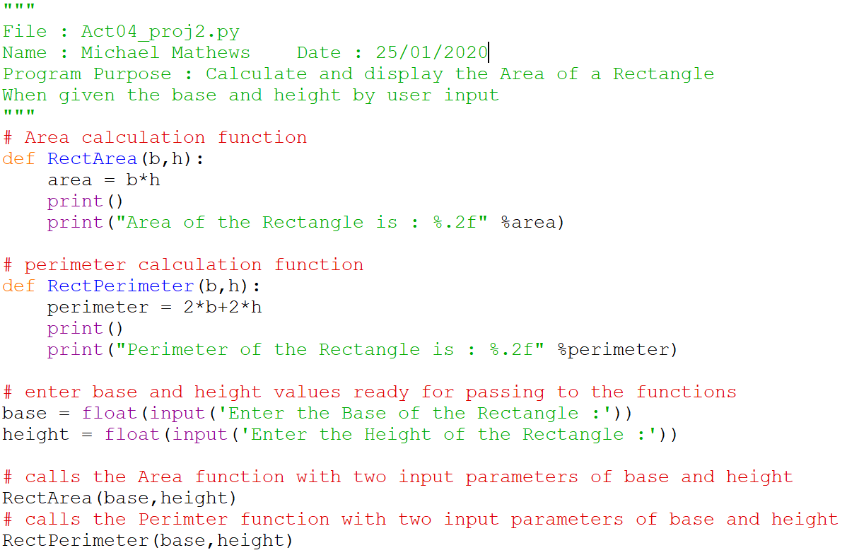

Activity 04  | P1 | P2 | P3 | P4 | P5 | P6

# **Project 3**

|  |
| --- |
| Enter the radius of the circle :24  Area of the circle is : 1809.56  Circumference of the circle is : 150.80 |

Write a Python program

**function** to Calculate the

**Area** and **Circumference**

of a Circle when the

Radius is entered by the user.

Answers should be given

with 2 decimal places

(**use pi =3.1416**)

Sample **output** should look like this:

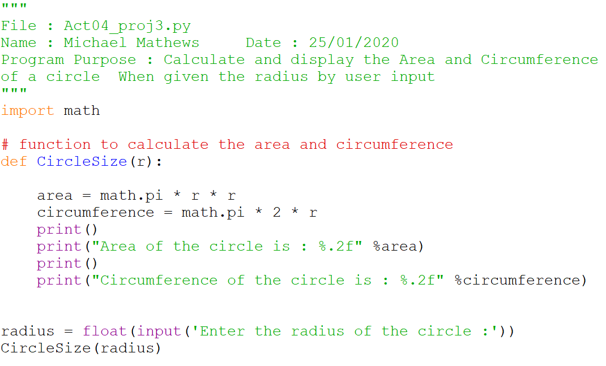

Activity 04  | P1 | P2 | P3 | P4 | P5 | P6

# **Project 4**

|  |
| --- |
| What is the base of the shape : **10**  What is the height of the shape : **6**  The Triangle area is 30.0 square units  The Rectangle area is 60 square units  The Square area is 100 square units |

Create a python program

that prompts a user for *height and base*

Then use functions

To give the

Area of **Triangle**

Area of **Rectangle**

and Area of **Square**

Sample **output** should look like this:

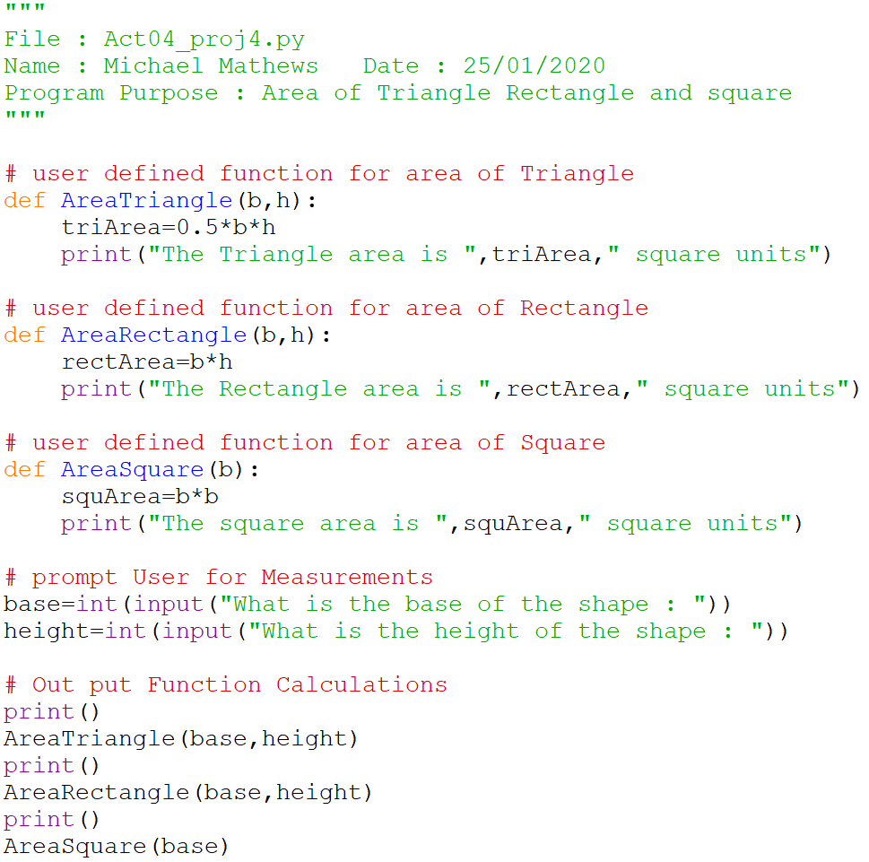

Activity 04  | P1 | P2 | P3 | P4 | P5 | P6

# **Project 5**

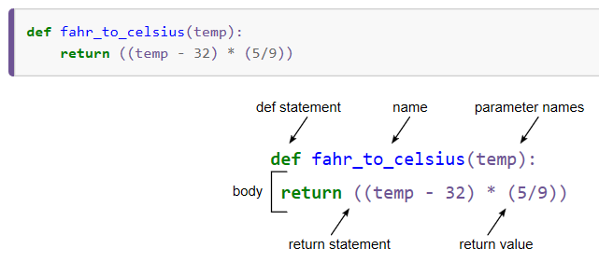Write a new Python program that defines functions that converts temperatures from Fahrenheit to Celsius and Celsius To Fahrenheit

Sample **output** should

look like this:

|  |
| --- |
| **Welcome to the Temperature Converter**  **1 - Convert Farenheit to Celsius**  **2 - Convert Celsius to Farenheit**  **3 - Display the freezing and boiling points**  **0 - Exit**  **Please Select:1**  **Please enter the temperature in Farenheit: 90**  **90.0 Farenheit in Celsius is 32.22222222222222 degrees.**  **1 - Convert Farenheit to Celsius**  **2 - Convert Celsius to Farenheit**  **3 - Display the freezing and boiling points**  **0 - Exit**  **Please Select:2**  **Please enter the temperature in Celsius: 25**  **25.0 Celsius in Farenheit is 77.0 degrees.**  **1 - Convert Farenheit to Celsius**  **2 - Convert Celsius to Farenheit**  **3 - Display the freezing and boiling points**  **0 - Exit**  **Please Select:3**  **The boling temperature is 100.0 C and 212 F.**  **The freezing temperatures are 0.0 C and 32 F.**  **1 - Convert Farenheit to Celsius**  **2 - Convert Celsius to Farenheit**  **3 - Display the freezing and boiling points**  **0 - Exit**  **Please Select:0**  **Thanks for use the Temperature convertor. Stay Cool !** |

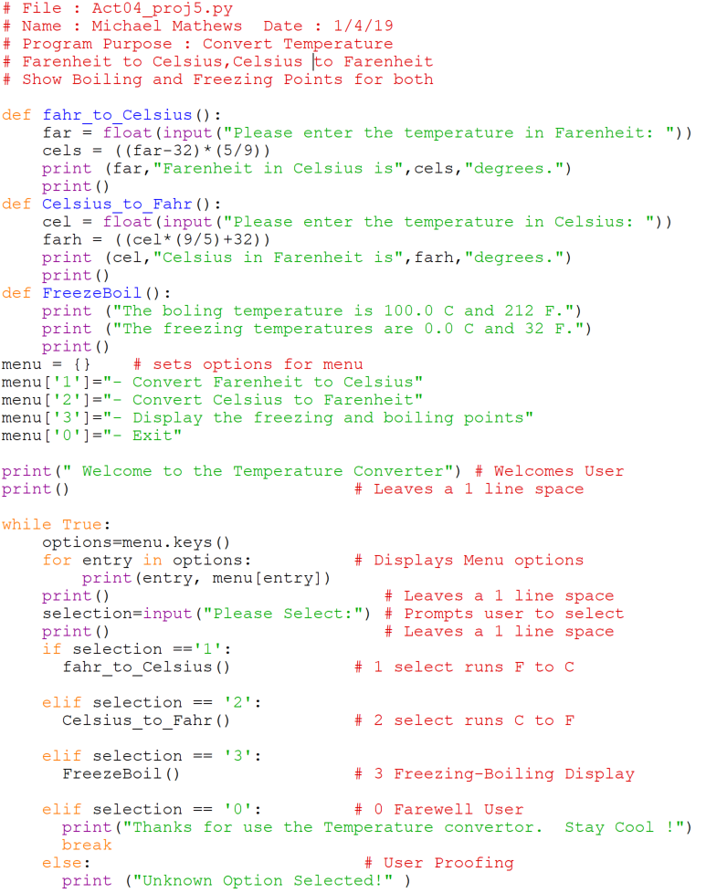

Activity 04  | P1 | P2 | P3 | P4 | P5 | P6

**Welcome to the Volume Solver!**

**-------------------------------**

**1) Volume of a cube**

**2) Volume of a box**

**3) Volume of a sphere**

**X) Exit**

**Your choice ? 1**

**side ? 3**

**Volume_of_cube with side 3.0 is 27.0 cubic units**

**Welcome to the Volume Solver!**

**-------------------------------**

**1) Volume of a cube**

**2) Volume of a box**

**3) Volume of a sphere**

**X) Exit**

**Your choice ? 2**

**Width ? 2**

**Length ? 3**

**Depth ? 4**

**Volume of rectangle with**

**width = 2.0, length = 3.0, depth = 4.0**

**is 24.0 cubic units**

**Welcome to the Volume Solver!**

**-------------------------------**

**1) Volume of a cube**

**2) Volume of a box**

**3) Volume of a sphere**

**X) Exit**

**Your choice ? 3**

**Radius? 4**

**Volume of sphere with radius 4.0 is 268.082573106329**

**Welcome to the Volume Solver!**

**-------------------------------**

**1) Volume of a cube**

**2) Volume of a box**

**3) Volume of a sphere**

**X) Exit**

**Your choice ? x**

**Goodbye!**

**>>>**

# **Project 6**

Create a Python program which

allows users a choice to select a shape and  
have the volume calculated and displayed.

Note users will need to be prompted

to enter the dimensions of the shape.

Sample **output** should look like this:**0 - Exit**

Note this module

as the **main** function,

**def main():**

Note the code to run this module

as the **main** function,

**main()**

**if __name__ == "__main__":**

**main()use the Temperature convertor. Stay Cool !**

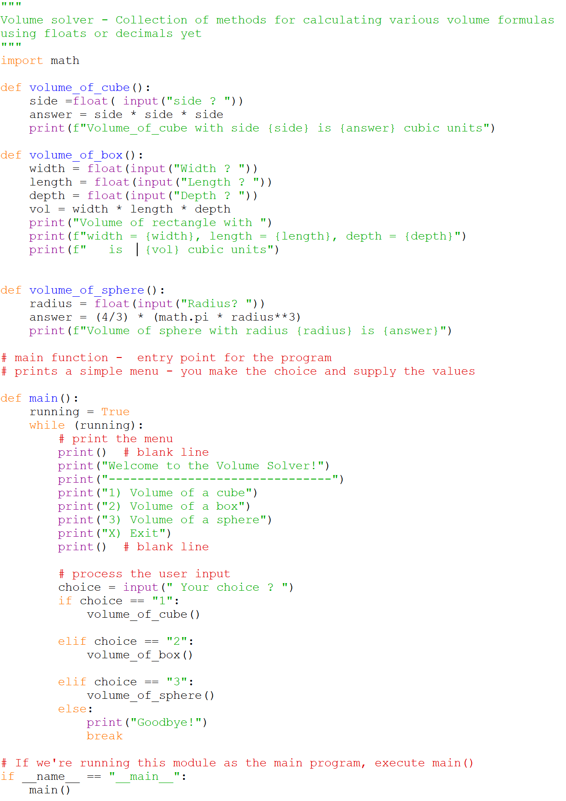

# **Challenge**

Create a Python program that checks and illustrates when 3 numbers are Pythagorean numbers ie a2 + b2 = c2

|  |
| --- |
| Enter three numbers seperated by a space: 6 8 10  Are these Pythogorean Triplets?  |  | .  6 | . 10  | .  | .  --------------  8  Ohh yeah!  Do you want to continue? (Y/N) y  Enter three numbers seperated by a space: 3 5 7  Are these Pythogorean Triplets?  Nope - wrong numbers.  Do you want to continue? (Y/N) |

